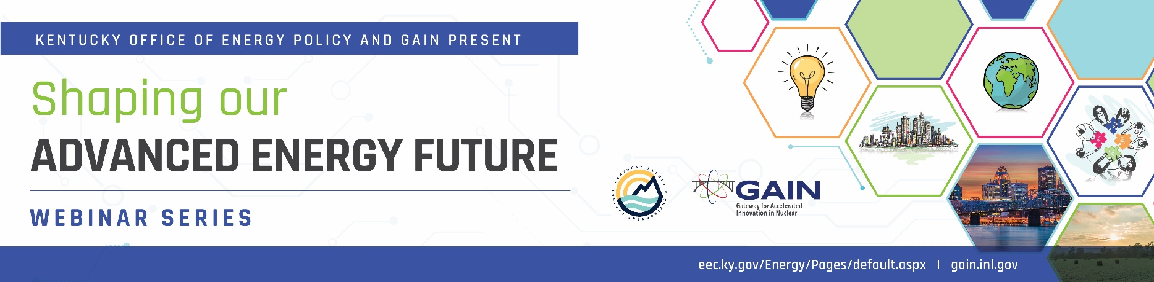

We are excited to invite you to an in-person workshop to continue our conversation about an advanced energy future for Kentucky. Please hold this date and time on your calendar.
RSVP to GAINevents@inl.gov if you will attend. Note: there will not be a virtual option for this meeting.
Date: June 29, 2022
Time: 8:30 am – 12:00 pm (Eastern)
Location: Kentucky Transportation Cabinet, Conference Center, 200 Mero Street, Frankfort, KY 40622
Session 1: Utility Perspectives
8:30 – 9:30 am Exploring Advanced Nuclear Energy
  - TVA: Joe Shea https://www.linkedin.com/in/joe-shea-a2591a2b/
  - Duke: Chris Nolan https://www.linkedin.com/in/chris-nolan-04b84724/
  - Southern: Ben Carmichael https://www.linkedin.com/in/ben-carmichael-40675713/

9:30 – 10:10 am Building a Demonstration Unit
- PacifiCorp: Chuck Tack https://www.linkedin.com/in/chuck-tack-meb-b892a27/

10:10 – 10:30 am Overview of State Actions Related to Nuclear Technology
- GAIN: Christine King

10:30 – 10:45 am Break
Session 2: Feasibility Study through Multiple Lenses: Technical, Markets, and Community Engagement
10:45-11:00 Technical Feasibilty: EPRI Technology Assessment Guide (not confirmed)
- Overview of guide: scope and how it works
11:00-11:30 Market/Economic Development
- Focusing on Energy intensive industry already in Kentucky, industry you would like to attract and what energy systems that can support that
11:30 – 12:00 Community Engagement
- KY specific education need to address nuclear history in state, evaluates lessons learned, and develop a strategy going forward

For more information, contact either Kenya Stump (kenya.stump@ky.gov) or Christine King (christine.king@inl.gov)

