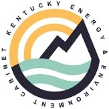

**Agenda**

**Energy Affordability Work Group**

**June 24th 10-12**

* **Welcome remarks – Secretary Goodman**
* **Office of Energy Policy – Overview and Introductions**
* **Review of Energy Affordability Website, LEAD Tool, Affordability Presentation, Affordability Study**
* **Review of Survey Results completed by participants**
* **Impact Stories**
* Community Action – call center story
* United Way – Data info on how many call they receive and percentage on utility assistance
* **KEY FOCUS AREAS**
* Data sharing
* Education
* Resource Gaps
* Policy
* Creation of Energy Affordability Guide
* **What is next?**
* **Questions - Dialogue**