Instrumentation Data Integrity Checklists

Online DPD Colorimetric Chlorine Analyzer (Example: Hach CL17)
Sample tap is a sufficient distance downstream of chemical feed points to ensure adequate mixing and sufficient reaction time (in turbulent flow conditions 10 x pipe diameters is suggested, in laminar flow conditions more than 100 × pipe diameters is suggested)
Sample tap orientation is “good” or “best” per Figure 1
Sample tap location is appropriate for measuring desired parameters (e.g., not measuring free chlorine after the addition of ammonia)
Sample conditioning kit is installed correctly (see Figure 2; the drain tee should be installed 2’ above the instrument cabinet to ensure the needed sample pressure in the analyzer)
Sample line length is not excessive (i.e., less than one minute residence time)
Sample flow rate to sample conditioning is between 200 to 500 mL/min
Correct reagents are installed (i.e., free chlorine indicator is installed when free chlorine is intended to be measured)
Reagents are not expired
Reagents bottles are connected to correct delivery tubes labeled “buffer” or “reagent” inside the instrument
Indicator reagent is prepared as specified by the manufacturer (indicator powder is mixed and fully dissolved in the indicator solution)
Stir bar is installed in the colorimeter cell (remove plug on the colorimeter and insert paper clip to remove)
Pressure plate on peristaltic pump is securely attached (to avoid backflow of the sample into the reagents)
Signal Averaging (SIGAVG) feature, which is used to average reading and prevent erratic recorder output, is disabled (default is SIGAVG = 1, which disables this feature)
Calibration settings are at factory default (OFFSET = 0.00), the analyzer is factory calibrated and does not require recalibration unless specified by regulatory agency
Record output span settings bracket the expected chlorine range of chlorine residual (i.e., factory default RECMIN = 0.00 mg/L @ 4 mA and RECMAX = 5.00 mg/L @ 20 mA)
Verify that the reading on the display of the online analyzer is the same as what is being shown on SCADA
Alarm settings are configured at desired trip points, if this feature is activated (i.e., toggle to ALARM menu and then RECALL WARNINGS to display active alarms)
Colorimeter cell is cleaned monthly when temperatures are less than 80 F and biweekly when temperatures are more than 80°F with 19.2 N sulfuric acid solution and cotton swabs
Pump tubing is replaced per manufacturers recommendation (i.e., if ambient temperature is <80° F, replace at six-month intervals; if >80°F, replace at three-month intervals)
Remaining analyzer tubing is replaced annually, per manufacturers recommendation
Analyzer performance is verified at least once per week (within ±0.10 mg/L or ±15% of expected value [whichever is larger], per EPA Method 334) with an EPA approved grab sample method (e.g., DPD colorimetric method), which has also been verified (e.g., Spec Check Secondary Gel Standards)

Online Amperometric Chlorine Analyzer (Example: Hach CL10sc with pH Sensor)
Sample tap is a sufficient distance downstream of chemical feed points to ensure adequate mixing and sufficient reaction time (in turbulent flow conditions 10 x pipe diameters is suggested, in laminar flow conditions more than 100 × pipe diameters is suggested)
Sample tap orientation is “good” or “best” per Figure 1
Sample tap location is appropriate for measuring desired parameters (e.g., not measuring free chlorine after the addition of ammonia)
Sample line length is not excessive (i.e., as close and direct as reasonably possible )
Sample flow rate is maintained in the desired range of 500 to 833 mL/min, which can be confirmed if the LED light on the flow sensor is on (the exact flow rate is not important as long as flow is constantly maintained in that range)
Pressure regulator (PRV or sample conditioning; see Figure 2) is installed if analyzer if it is under the influence of pressure/flow variations (e.g., under the influence of a storage tank or pumps)
Analyzer is not under the influence of a heat source or in direct sunlight
Analyzer is configured to measure the desired parameters (toggle to sensor setup menu), such as chlorine (total or free), pH (optional), and temperature (optional)
Tubing (Teflon or PVDF) is replaced annually, per manufacturers recommendation
Sensor flow cells are clean (i.e., free of sediment deposits and film, not discolored)
Membrane cap on the chlorine sensor is replaced at least once per year (during replacement the electrode should be polished and electrolyte solution should be replaced)
Electrolyte solution in the chlorine sensor is replaced every 3 to 6 months
Electrolyte solution is not expired
Chlorine sensor is replaced every three years
Measurement span settings are at desired range (toggle to sensor setup menu)
Alarm settings are configured at desired trip points, if this feature is activated (i.e., toggle to Sensor Setup menu and then Cal Watch to display active alarms)
Chlorine analyzer performance is verified (and calibrated if needed) at least once per week (within ±0.10 mg/L or ±15% of expected value [whichever is larger], per EPA Method 334) with an EPA approved grab sample method (e.g., DPD colorimetric method), which has also been verified (e.g., Spec Check Secondary Gel Standards)
pH sensor is calibrated (see Chlorine Sensor User Manual for details) at least weekly
pH sensor is cleaned and inspected every 90 days (see pH Sensor User Manual for details)
pH sensor is “rebuilt” (standard cell solution and salt bridge is replaced) every 3 to 6 months
pH sensor is replaced every 4 to 5 years

Online Nephelometric Turbidimeter w/90° Detector (Example: Hach 1720E)
Sample tap is a sufficient distance downstream of chemical feed points to ensure adequate mixing and sufficient reaction time (in turbulent flow conditions 10 x pipe diameters is suggested, in laminar flow conditions more than 100 × pipe diameters is suggested)
Sample line tapped into larger process pipe and sample tap orientation is “good” or “best” per Figure 1
Sample tap location is appropriate for measuring desired parameters (e.g., filter-to-waste sample location is representative of filter-to-waste sample).
Sample line length is not excessive (i.e., as close and direct as reasonably possible )
Sample line does not have excessive elevation changes
Sample pumping is to be avoided, if possible
Sample flow rate to turbidimeter is between 200 and 750 mL/min and is verified quarterly (samples with high turbidity should operate at as high as flow rate as possible and without a bubble trap, while samples with low turbidity should operate at as low as flow rate as possible)
Turbidimeter is installed indoors or in a location that is isolated from vibration, heat, and direct sunlight
Turbidimeter head is securely seated on the turbidimeter body
Lamp is replaced once per year, per manufacturers recommendation
Turbidimeter is calibrated per manufacturer’s specifications at least once every three months during normal operation and after any significant maintenance or repair (check calibration/verification history)
Turbidimeter body, bubble trap, and photocell window (do not disassemble or scratch) is thoroughly cleaned and rinsed as needed, or prior to calibration (see user’s manual for details)
Verify that the reading on the display of the online analyzer is the same as what is being shown on SCADA
Turbidimeter photocell contains a small air bubble
Turbidimeter output mode is set to “HOLD” during calibration and maintenance activities
Turbidimeter error mode is set to “TRANSFER” during normal operation and transfer value is set to 0.00 or 20.00 NTU
Turbidimeter calibration is verified at least once every weekly
Turbidimeter date and time stamp is verified during calibration and after power outages
Turbidimeter sample line is inspected during calibration and replaced as needed (raw water sample lines will need to be replaced more frequently that filtered water sample lines)
Turbidimeter lamp assembly is replaced at least once per year (per manufacturer’s specifications)
Turbidimeter data log interval (DATALOG INTRVL) is at desired setting (≤ 1 minute is recommended)
Turbidimeter output signal span is set to 0.00 to 5.10 NTU
Turbidimeter bubble reject (BUBBLE REJECT) setting is at desired setting (enabled, or yes, is recommended)
Turbidimeter signal averaging setting (SIGNAL AVG) is at desired interval (30 second interval is recommended)
Turbidimeter offset value (OFFSET) is at desired setting (0.00 NTU is factory default)

Online Laser Turbidimeter (Example: Hach FilterTrak 660sc)
Sample tap is a sufficient distance downstream of chemical feed points to ensure adequate mixing and sufficient reaction time (in turbulent flow conditions 10 x pipe diameters is suggested, in laminar flow conditions more than 100 × pipe diameters is suggested)
Sample line tapped into larger process pipe and orientation is adequate (see Figure 1)
Sample line length is not excessive (i.e., as close and direct as reasonably possible )
Sample flow rate to turbidimeter is between 100 and 750 mL/min (samples with high turbidity should operate at as high as flow rate as possible, while samples with low turbidity should operate at as low as flow rate as possible)
Turbidimeter is installed indoors in location that is isolated from vibration, heat, and direct sunlight
Turbidimeter head is securely seated on the turbidimeter body
Turbidimeter is calibrated per manufacturer’s specifications at least once every three months during normal operation and after any significant maintenance or repair (check calibration/verification history)
Turbidimeter is cleaned at least once per month and prior to calibration (see user’s manual for details)
Turbidimeter output mode is set to “hold” during calibration and maintenance activities
Turbidimeter calibration is verified at least once every month (check calibration/verification history)
Turbidimeter data log interval (DATALOG INTRVL) is at desired setting (≤ 1 minute is recommended)
Turbidimeter bubble reject (BUBBLE REJECT) setting is at desired setting (enabled, or yes, is recommended)
Turbidimeter signal averaging setting (SIGNAL AVG) is at desired interval (30 second interval is recommended)
Turbidimeter offset value (OFFSET) is at desired setting based on calibration (0 mNTU is factory default)

Online Nephelometric Laser Turbidimeter w/360° x 90° Detector (Example: Hach TU5300 sc, Hach TU5400 sc)
Sample tap is a sufficient distance downstream of chemical feed points to ensure adequate mixing and sufficient reaction time (in turbulent flow conditions 10 x pipe diameters is suggested, in laminar flow conditions more than 100 × pipe diameters is suggested)
Sample line tapped into larger process pipe and sample tap orientation is “good” or “best” per Figure 1
Sample tap location is appropriate for measuring desired parameters (e.g., filter-to-waste sample location is representative of filter-to-waste sample).
Sample line length is not excessive (i.e., as close and direct as reasonably possible)
Sample line does not have excessive elevation changes
Sample pumping is to be avoided, if possible
Sample line pressure does not exceed 87 psi
Sample flow rate to turbidimeter is between 200 and 500 mL/min and is verified quarterly (samples with high turbidity should operate at as high as flow rate as possible and without a bubble trap, while samples with low turbidity should operate at as low as flow rate as possible); if equipped, confirm flow rate on flow sensor
Turbidimeter is installed indoors or in a location that is isolated from vibration, heat, and direct sunlight
Turbidimeter is not installed in immediate proximity of televisions, radios, computers, or other electronic equipment. This instrument is sensitive to electromagnetic and electromechanical interference.
Turbidimeter is installed in a vertical position and is level
Vial is cleaned at least once every three months
Vial is replaced at least every two years
Desiccant cartridge is replaced at least every two years or as identified by instrument notification
Turbidimeter is calibrated per manufacturer’s specifications at least once every three months during normal operation and after any significant maintenance or repair (check calibration/verification history)
Verify that the reading on the display of the online analyzer is the same as what is being shown on SCADA
Turbidimeter output mode is set to “HOLD” during calibration and maintenance activities
Turbidimeter error mode is set to “TRANSFER” during normal operation and transfer value is set to 0.00 or 20.00 NTU
Turbidimeter calibration is verified at least once every week
Turbidimeter date and time stamp is verified during calibration and after power outages
Turbidimeter sample line is inspected during calibration and replaced as needed (raw water sample lines will need to be replaced more frequently that filtered water sample lines)
Turbidimeter data log interval (DATALOG INTRVL) is at desired setting (≤ 1 minute is recommended). The default setting for this instrument is 10 minutes, which is greater than desired.
Turbidimeter output signal span is set to 0.00 to 5.1 NTU
Turbidimeter bubble reject (BUBBLE REJECT) setting is at desired setting (enabled, or yes, is recommended)
Turbidimeter signal averaging setting (SIGNAL AVG) is at desired interval (30 second interval is recommended)
Turbidimeter offset value (OFFSET) is at desired setting (0.00 NTU is factory default)

Portable Colorimeter (Example: Hach Pocket II, DR800, or DR900 Colorimeters)
Appropriate method (or program number) is used for anticipated sample concentration (LR, MR, HR; see Table 1)
Appropriate sample volume is used (10 or 25 mL; see Table 1)
Appropriate sample cell is used (plastic or glass; see Table 1)
Appropriate sample reaction time is used (total chlorine reaction time is temperature dependent; see Table 1 and/or user’s manual)
Sample cells are clean and not scratched
Sample cells are consistently oriented in the appropriate position in the colorimeter (i.e., white diamond consistently faces towards the front of the instrument)
Sample cells are consistent material and condition (e.g., visually identical)
Instrument cap is securely placed on top of instrument prior to analysis
Excess liquid (e.g., condensation) and finger prints are wiped from sample cells prior to analysis with a lint-free cloth
Appropriate reagent is used (free or total chlorine; for 10 or 25 mL samples; see Table 1)
If a reagent dispenser is used (e.g., Hach SwiftTest kit), confirm that humidity is not causing reagent to clog in the dispenser
If a reagent dispenser is used (e.g., Hach SwiftTest kit), confirm that the reagent cartridge is used within 6 months after opening
Reagents are not expired
Reagent blank value is determined for each new lot of reagent (i.e., replace the sample in the test procedure with deionized water to determine reagent blank value, which will be subtracted from all sample results to account for “baseline” color development). It is recommended that the reagent blank value is written on the package of reagent, including date and operator initials.
Separate sample cells are labeled and used for free and total chlorine analysis
Colorimeter performance is verified (e.g., Spec Check Secondary Gel Standards, primary standards) at least weekly during routine use or before each use during infrequent use
Instrument is using the most current software/firmware (check manufacturer’s website)
Instrument is re-zeroed at each sample location (if used for distribution system sampling)
Instrument is displaying the desired test results (concentration, Abs, %T)
Instrument is displaying the desired units (e.g., mg/L as NH₃-N vs. NH₃)
Sample cells are rinsed well between samples using deionized water or fresh sample
Sample cells are capped and gently inverted prior to analysis (after the reaction time is complete) to remove any bubbles that may have accumulated on the sample cell wall (common issue with plastic sample cells)
Samples are not left in direct sunlight (both before and after the addition of reagent)
Factory default calibration is not adjusted (unless asked to do so by regulatory agency)
Samples are analyzed immediately and are not preserved for later analysis
Sample locations are adequately flushed, so that the sample is representative water quality at the desired location (i.e., calculated flush time concept)
Plastic containers are not used to collect samples (plastic can have chlorine demand)
Operator is following the most recent version of the method procedure (method procedures are updated periodically to improve performance; check manufacturer’s website)
Operator is aware of potential interferences with reagents (e.g., oxidized manganese can interfere with DPD reagent)

Portable Parallel Analyzer (Example: Hach SL1000)
Instrument is using the most current software/firmware (check manufacturer’s website)
Analyzer performance is verified with a primary or secondary standard (e.g., System Verification Chemkey) at least once per week during routine use or before each use during infrequent use
Probes (e.g., pH, conductivity) are calibrated before each use
Reagents are not expired
Operator is following the most recent version of the method procedure (method procedures are updated periodically to improve performance; check manufacturer’s website)
Operator is aware of potential interferences with reagents (e.g., manganese can interfere with DPD reagent)
Sample locations are adequately flushed, so that the sample is representative water quality at the desired location (i.e., calculated flush time concept)
Appropriate Chemkey is used for desired method; the analyzer automatically identifies the parameter(s) being analyzed when Chemkey(s) are installed and/or probe(s) are connected
Chemkeys are installed and recognized by the analyzer without receiving an error message (e.g., expired reagent, Chemkey leaked) prior to placing in sample tray
Sample tray is rinsed well between samples using deionized water or fresh sample
Appropriate sample volume is added to sample tray (i.e., filled to line)
Samples are analyzed immediately and are not preserved for later analysis

Benchtop Turbidimeter (Example: Hach 2100 Series)
Turbidimeter is located on stable, level surface that is free of vibration
Turbidimeter is not located in direct sunlight or near a heat source
Turbidimeter is calibrated at least every three months or as specified by regulatory agency
Turbidimeter is calibrated per manufacturers recommendations (e.g., Hach 2100Q should be calibrated at 20, 100, and 800 NTU and then verified at 10 NTU)
Turbidimeter is calibrated using formazin or other approved standards. Consult safety data sheet to determine appropriate handling and disposal.
Turbidimeter and standards are both at ambient temperature during calibration
Sealed vial standards (e.g., StablCal) standards are stored at approximately 40°F, if used less than once per month
Turbidimeter is left “on” 24 hours a day if it used regularly (per manufacturer’s recommendation)
Turbidimeter is “on” at least 30 minutes (ratio on) and 60 minutes (ratio off) prior to analysis
Silicone oil is used on sealed vial standards and sample vials prior to calibration/analysis (see user’s manual for procedure)
Vials are placed in the cell holder with the triangle on the vial aligned with the reference mark on the sample cell holder
Turbidimeter calibration is verified at least once per week using secondary standards (e.g., Gelex), which should be ±5% of the value recorded on the secondary standard vial
Sample cells are not dirty, scratched, or damaged (see user’s manual for cleaning procedure)
Sample cells are free of condensation (common when water temperature is cooler; see user’s manual)
Sample cells are filled with distilled or deionized water during storage
Sample cells are indexed and matched (see user’s manual for procedure)
Samples are mixed by gentle inversion prior to analysis
Air bubbles are removed, if present (see user’s manual for various techniques)
Samples are analyzed immediately after they are collected (changes in temperature and settling can occur)
Turbidimeter ranging setting (RANGE) is set to “automatic” (recommended by manufacturer)
Turbidimeter signal averaging setting (SIGNAL AVG) is “on” (recommended by manufacturer)
Turbidimeter ratio setting (RATIO) is “on” (recommended by manufacturer)

Appendix A: Supplemental Information
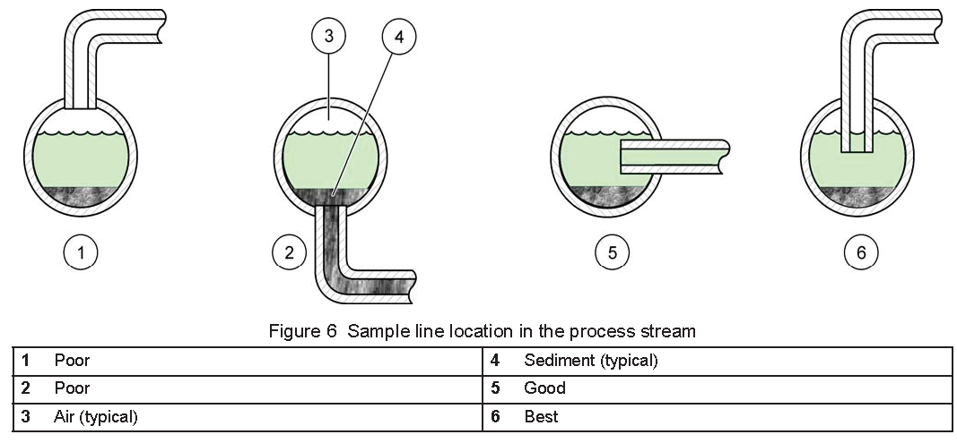
Source: Hach Company (2014)
Figure 1: Sample Line Location in Process Stream (Hach Company)
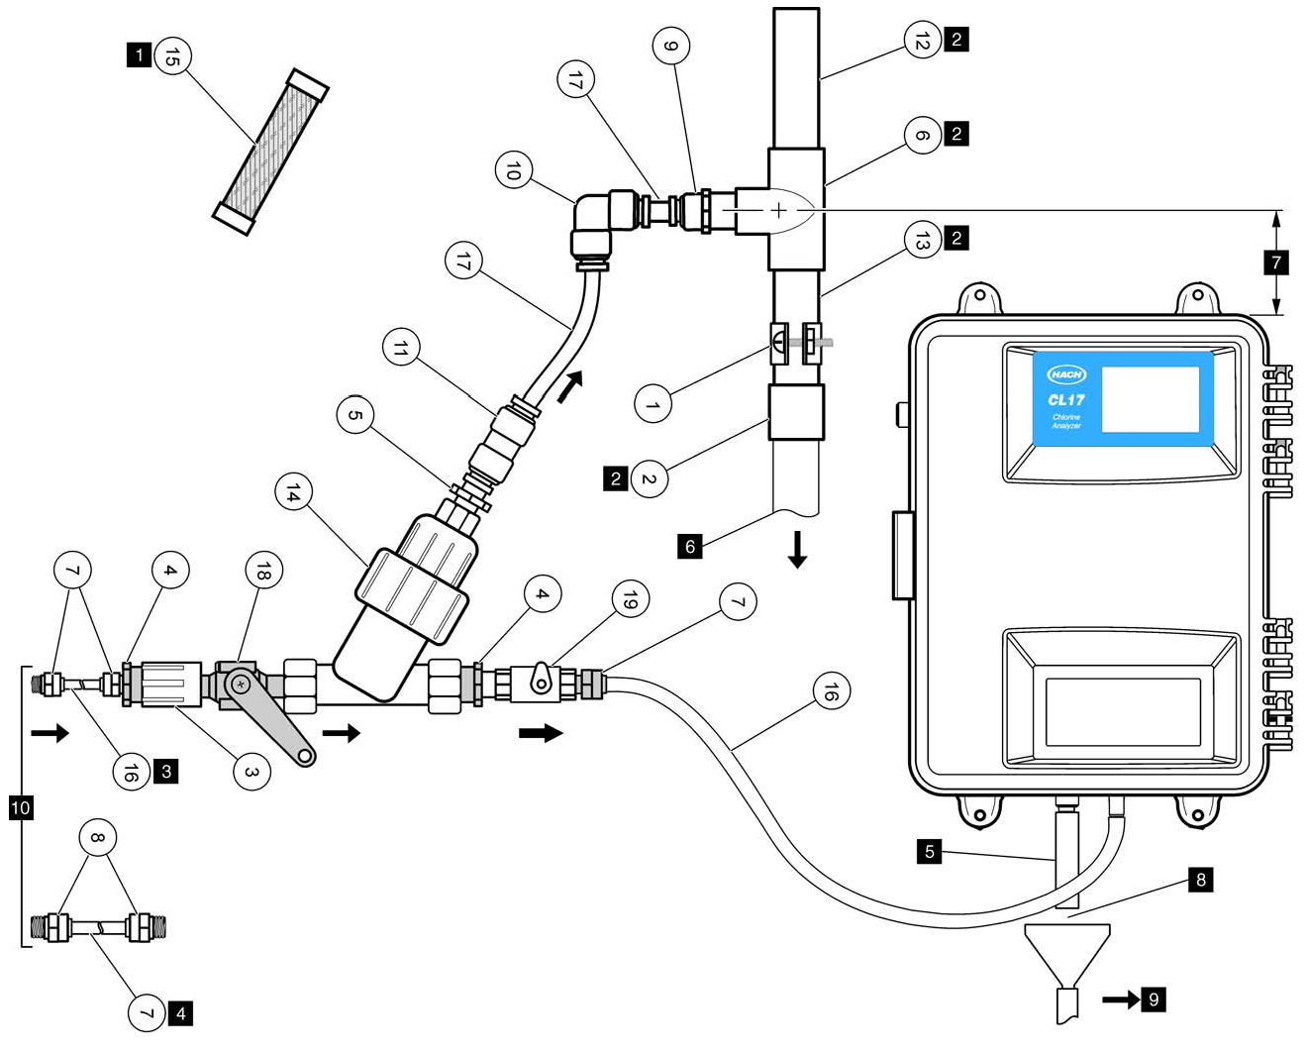
Source: Hach Company (2014)
Install Sample Flow Regulator 24 inches above Instrument
Figure 2: Sample Conditioning Kit Configuration

Table 1: DPD Chlorine Method Summary for Portable Colorimeters (Hach Company)
Colorimeter Type | Method Specifications | Low Range | Mid-Range | High Range
Colorimeter Type | Method Specifications | (0.02 to 2.00 mg/L) | (0.05 to 4.00 mg/L) | (0.1 to 8.0 mg/L)
Hach  Pocket II | Method | Total: 8167  Free: 8021 | N/A
Hach  Pocket II | Cell Type | Glass | N/A | Plastic (1 cm)
Hach  Pocket II | Sample Volume | 10 mL | N/A | 5 mL
Hach  Pocket II | Powder Pillow | 1 x 10 mL pillow | N/A | 2 x 10 mL pillows
Hach  Pocket II | Precision | @ 1.00 mg/L ± 0.05 mg/L | N/A | @ 5.0 mg/L ± 0.2 mg/L
Hach  Pocket II | Reaction Time | Total: 3 min (varies by temp.)  Free: Immediate (< 1 min) | N/A | Total: 3 min (varies by temp.)  Free: Immediate (< 1 min)
Hach  DR 800 Series | Method | Total: 8167  Free: 8021 | Total: 10250  Free: 10245 | N/A
Hach  DR 800 Series | Program Number | 9 | 114 | N/A
Hach  DR 800 Series | Cell Type | Glass | Glass | N/A
Hach  DR 800 Series | Sample Volume | 10 mL | 10 mL | N/A
Hach  DR 800 Series | Powder Pillow | 1 x 10 mL pillow | 1 x 25 mL pillow | N/A
Hach  DR 800 Series | Precision | @ 1.00 mg/L ± 0.01 mg/L | @ 1.50 ± 0.02 mg/L | N/A
Hach  DR 800 Series | Reaction time | Total: 3 min (varies by temp.)  Free: Immediate (< 1 min) | Total: 3 min (varies by temp.)  Free: Immediate (< 1 min) | N/A
Hach  DR 900 Series | Method | Total: 8167  Free: 8021 | Total: 10250  Free: 10245 | N/A
Hach  DR 900 Series | Program Number | 80 | 87 | N/A
Hach  DR 900 Series | Cell Type | Glass | Glass | N/A
Hach  DR 900 Series | Sample Volume | 10 mL | 10 mL | N/A
Hach  DR 900 Series | Powder Pillow | 1 x 10 mL pillow | 1 x 25 mL pillow | N/A
Hach  DR 900 Series | Precision | @ 1.25 mg/L ± 0.02 mg/L | @ 2.10 mg/L ± 0.02 mg/L | N/A
Hach  DR 900 Series | Reaction Time | Total: 3 min (varies by temp.)  Free: Immediate (< 1 min) | Total: 3 min (varies by temp.)  Free: Immediate (< 1 min) | N/A

