

Andy Beshear
GOVERNOR

ENERGY AND ENVIRONMENT CABINET
DEPARTMENT FOR ENVIRONMENTAL PROTECTION
300 Sower Boulevard
Frankfort, Kentucky 40601
Phone: (502) 564-2150
Fax: 502-564-4245
Rebecca Goodman
SECRETARY

Anthony R. Hatton
COMMISSIONER

July 30, 2025

Re: 2026 Illegal Open Dump Cleanup Grant Program

Dear Judge or 109 Board Chair:

The Division of Waste Management (DWM) is pleased to announce funding for the cleanup of illegal open dumps. Please be sure to read this letter and the attachments carefully and to fill out the application in its entirety.

The grant period is 14 months: from January 1, 2026 until February 28, 2027. The county is required to spend the grant funds during that time, unless the county requests an extension and receives approval from the cabinet.

- Due to limitations in available grant funds, we will use a prioritization process, and it is possible that the Division will not award all eligible grant requests. The prioritization process will rank all sites based on their location relative to sensitive receptors or protected areas (streams, wetlands, supply wells, etc.); the relative hazard posed by the contents of the dump; and the size of the dump.
- In order to control costs, and to ensure that grant money is appropriately distributed, there will be an increased emphasis on making certain that illegal open dump cleanups are consistent in scope and scale across the state. The Dump Grant Review Committee will compare cost estimates from each dump application to the information generated from the pre-inspection. If the cost estimate for a dump is inconsistent with the findings of the pre-inspection, the committee may require additional information, such as a work plan or a justification of proposed equipment and labor costs. In a situation where the cost estimate appears excessive, the committee may deny the grant request, or may award a reduced amount.
- Another point of emphasis with the Dump Grant Review Committee will be ensuring that each site is appropriate for the dump grant program, i.e., that the site either has no identifiable responsible party, or that the responsible party is not able to clean the site themselves. To that end, the Committee may require that the county show they have taken reasonable steps to identify and pursue cleanup with the responsible party, or otherwise justify that the site is appropriate for an illegal open dump grant, before a grant application is considered. Demolition projects (demolition of structures) are not eligible for funding.

@KentuckyEEC | EEC.KY.GOV  An Equal Opportunity Employer M/F/D

- As in the past, we are allowing counties to clean dumps at their own expense before applying for grant funds and then apply for reimbursement of the actual costs, as long as the county 1.) Gets a pre-inspection before cleaning the dumpsite; 2.) Provides a cost estimate to DWM or requests that DWM personnel be on site during cleanup; and 3.) Gets a post-inspection of the cleaned dumpsite, before submittal of the application. Note that the application will be subject to the prioritization ranking, funding availability and other applicable criteria in the grant cycle in which the county submits the application, and that the award of grant funding for all eligible requests for reimbursement may not be possible.
- If the project budget is insufficient to complete the dump cleanup, the county is responsible for completing the cleanup and covering the cost difference at its own expense. If the county notifies and receives the concurrence of DWM on the presence of unexpected site conditions or volumes of waste that were not evident during the pre-inspection, the county then has the option to pursue a reimbursement grant in a later grant cycle. DWM may decline to award reimbursement grants for sites where it is not clear that unforeseen site conditions or volumes of waste were encountered, or due to limited funds in that grant cycle.
- An “illegal open dump,” as defined in 401 KAR 49:080, Section 1, means any facility or site for the disposal of solid waste that does not have a valid permit issued by the cabinet or does not meet the environmental performance standards established by the cabinet and is equal to or greater than two (2) consolidated cubic yards of solid waste.
- Applications for an Illegal Open Dump Cleanup Grant are due by 4:30 p.m. EST on November 3, 2025. Any application received after this date or any incomplete application, will not be considered for the grant program unless an extension has been requested by the county and approved by the cabinet. Applications must include the signed application, Illegal Open Dump Grant Cleanup Agreement and the two-page Illegal Open Dump Grant Program Estimated Expense Worksheet (for each illegal open dump listed on the application).
- For FEMA rates for equipment, see Attachment D. For FEMA rates for equipment not listed on Attachment D, see www.fema.gov.
- A pre-inspection of all illegal open dumps by the Division of Waste Management inspectors before you apply for an Illegal Open Dump Cleanup Grant. (Check with a DWM regional office inspector for a copy of the pre-inspection form.)
- A match of twenty-five (25%) percent of the grant amount, either in-kind or actual dollars, is required for individual dumps costing less than $50,000. Note that the formula in the application used to calculate the “Grant Amount Requested” and County’s “Match Amount” has changed from previous Open Dump Grant applications. Complete the form using the calculations in the application, which will result in a county match amount that equals 25% of the grant amount requested.
- Note: If the county’s estimates the cleanup cost for a dump on the Estimated Expense Worksheet greater than $50,000, the cabinet does not initially impose a match requirement. If the Final Expense Worksheet shows that the actual cleanup cost is less than $50,000, the cabinet may determine not to waive the match requirement, and the county will be required to provide a match. If you have any questions about this, contact Lisa Evans at lisa.evans@ky.gov or at (502) 782-6355.

- NOTE -- only the actual, documented costs of remediation as itemized in detail on the Final Expense Worksheet are eligible for funding, even if a contract amount is higher. This is true even if a contractor, under a lump-sum bid, completed the cleanup of the dump – only the actual, documented costs of remediation as itemized in detail on the Contractor Cost Sheet (page 3 of the Final Expense Worksheet) are eligible for funding.
- ADDITIONAL NOTE – demolition of structures (of any size) is not eligible for funding.
- The forms attached are incorporated and are the required forms to use for this grant.

If you wish to participate in the Illegal Open Dump Grant Cleanup Program, submit a completed Grant Application, Signed Grant Agreement and the Illegal Open Dump Program Estimated Cost Estimate Worksheets by 4:30 p.m. EST on November 3, 2025, via email to lisa.evans@ky.gov.

We hope your county will avail itself of this opportunity to fund the cleanup of illegal open dumps.
Please contact me at lisa.evans@ky.gov or 502-782-6355.

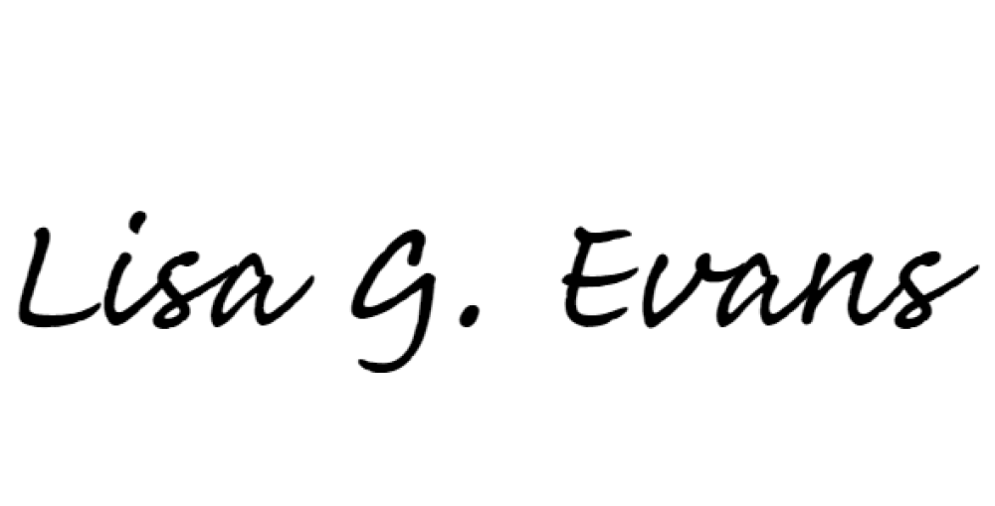
Sincerely,

Lisa G. Evans
Environmental Scientist Consultant Recycling & Local Assistance Branch

c: County Solid Waste Coordinator Attachments:
Illegal Open Dump Cleanup Grant Application (Attachment A) Illegal Open Dump Cleanup Grant Agreement (Attachment B) FEMA Rates for Equipment (Attachment D)
Illegal Open Dump Cleanup Grant Program Estimated Expense Worksheet Illegal Open Dump Cleanup Grant Program Final Expense Worksheet Risks and Recommended Precautions

