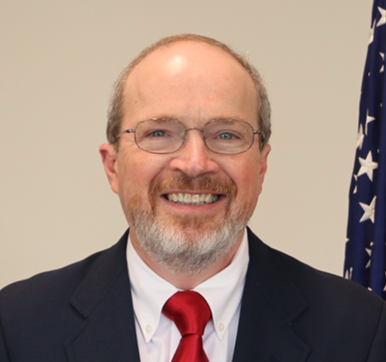
Dennis R. Hatfield
Division Director
Division of Oil and Gas
Commonwealth of Kentucky
Energy and Environment Cabinet
Department for Natural Resources

Dennis R. Hatfield has served as Director of the Kentucky Division of Oil and Gas since appointment in January 2017. This division is composed of a central administrative office in Frankfort, plus four regional districts, with 16 field inspectors and 8 administrative personnel.

His prior experience in private industry includes positions of responsibility as an engineer, superintendent, mine manager, business executive, and professional consultant for various energy companies in Central Appalachia. Most recently he served as Vice President, Kentucky and West Virginia Operations for Rhino Energy, which included oversight of coal mining operations, a small oil production company, and other support/services groups.

Dennis has 38 years’ experience in engineering, geology, operations management, resource development, risk analysis, and senior management positions within the energy field.

Dennis is a Licensed Professional Engineer in KY, WV, and Utah. He is a graduate of Virginia Tech with a B.S. in Mining Engineering, there named Distinguished Mining Engineering Alumni in 2004. He currently resides at Louisa, KY with his wife Trish and son Aaron.

