

Office of Reclamation and Guaranty Fund
300 Sower Blvd, 2nd Floor
Frankfort, Kentucky 40601
(502) 564-6940

RGF-1 eForm User Guide
March 10, 2026

Table of Contents
Introduction 2
Benefits 3
RGF-1 eForm Overview 3
Filing a New Quarterly Report 4
RGF-1 Permittee Information Tab 5
Quarterly Fee Report Part 1 Tab 8
Reporting for Permits Classified as COMB, SURF and UNDG 9
Reporting for Permits Classified as NPRD 11
Reporting for Permits Classified as DORM 12
Permit Summary Tab and the Quarterly Fee Report Part 1 Tab 13
Adding Permit Records to the Quarterly Report 14
Reporting for only 1 permit 14
Reporting for multiple or all permits 15
Quarterly Fee Report Part 2 Tab 15
Paying for the Quarterly Report 17
Filing an Amended or Corrected Quarterly Report 19

Introduction
The Kentucky Reclamation Guaranty Fund (KRGF) was established on March 22, 2013, by House Bill 66, now codified as Kentucky Regulatory Statute (KRS) 350.500 through 350.521. The legislation established the KRGF, the Fund Commission and the Office of Reclamation and Guaranty Fund (ORGF), to support the commission and administer its affairs.
The KRGF permittee members must report tonnage for any coal production, by permit, quarterly. If coal was either not produced or not expected to be produced you must report either quarterly or optionally pre-pay for all quarters for the year by April 30.
To standardize and modernize the reporting process, a web-based digital eForm version of the KRGF Quarterly Fee Report Part 1 and Part 2 was created to replace the KRGF Portal online version.

Benefits
- Permittees will be able access the Reclamation Guaranty Fund (RGF) RGF-1 Part 1 and Part 2 eForm via the Kentucky Energy and Environment Cabinet (EEC) eForm portal.
- Permittees will be able to file quarterly or annual reports and submit payments online.
- Permittees will be able to start filing a quarterly or annual report, save it for later retrieval and submit it with payment options at their convenience.
- An invoice will be generated in the Surface Mining Information System (SMIS) for the permit(s) the permittee reported on. It will be a new reporting invoice if the permits have not previously been reported on or an amended invoice if they were reported on and the report is being updated.
- Permittees will be able to view their submitted eForms via the Kentucky EEC eForm website dashboard in the My Completed eForms folder.
- ORGF staff will get an email notification when a permittee has submitted an eForm.
- Permittees will be able to download a copy of their RGF-1 eForms.

RGF-1 eForm Overview
The RGF-1 form is used by KRGF members to submit quarterly reports for each of their mining permits. Part 1 of the form indicates for each of their permits, by Quarter and Year, if coal was produced during the quarter or if the mine permit was in a Non-Production Mining (NPRD) or Dormant Mining Operation (DORM) status. The company can also use the form to file an amended or corrected Quarterly Fee Report, as explained in the Filing an Amended or Corrected Quarterly Report section.
Start by logging on to the EEC eForms web site at: Kentucky EEC eForms.
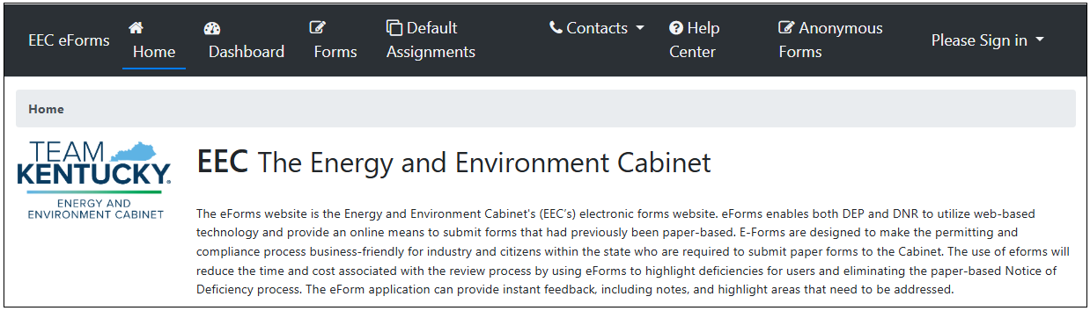
You will need to enter your logon information to access your Dashboard or to create a new eForm. If you have forgotten your password or need to register for the first time those options as available by clicking on the appropriate link.
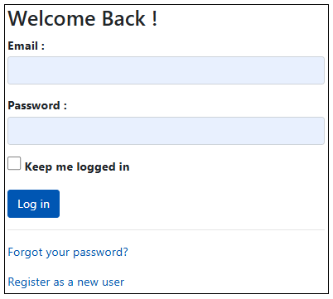
The eForm consists of four tabs: Permittee Information, Quarterly Fee Report Part 1, Permit Summary and Quarterly Fee Report Part 2. At the bottom of each tab is a button to ‘Click to Save Values for Future Retrieval’ and a button to ‘Click to Continue to Pre-Payment’.
The ‘Click to Save Values for Future Retrieval’ will save the data that has been entered on the form and add a copy of the eForm to the user’s EEC eForms Dashboard My Incomplete eForms tab that you can access and complete later.
The ‘Click to Continue to Pre-Payment’ button will generate the invoice in SMIS and navigate the user to the payment module.
Required fields are indicated by this symbol (*).

Filing a New Quarterly Report
- When the RGF-1 eForm displays, it will default to the Permittee Information tab.
- The cursor will default to the Permittee ID field.

RGF-1 Permittee Information Tab
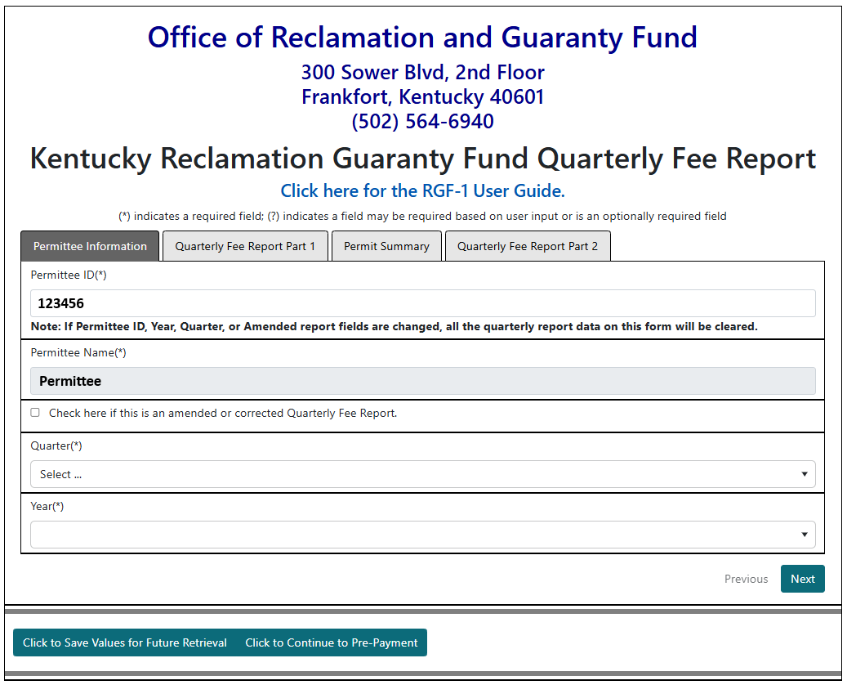
- Enter a valid Permittee ID and use the enter key to display the Permittee Name.
- If the Permittee Id that was entered is less than 6 digits, the error message below will display. The field will not allow more than 6 digits to be entered.
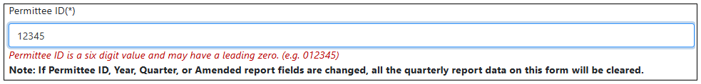
- If the Permittee Id that was entered is invalid, the error message below will display.
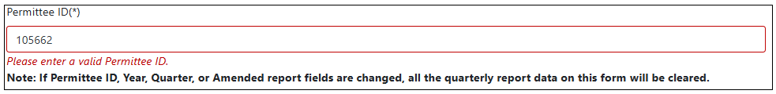
- If an amended report is being filed, the “Check here if this is an amended or corrected Quarterly Fee Report” checkbox must be checked to display permits on the Quarterly Fee Report Part 1 tab that have a reporting record. If it is not checked, only permits that have not had a quarterly report filed will display.
- Clicking in the Quarter dropdown box will display selections for Quarters 1 through 4. Select the Quarter for which the quarterly report is being submitted.
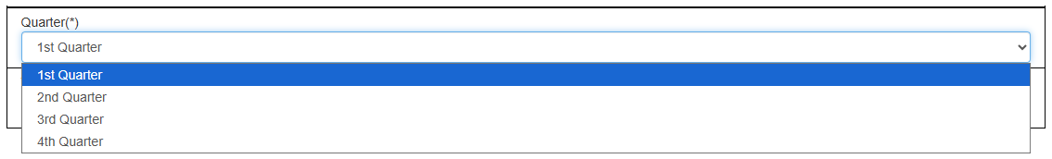
- The Year field will default to blank. Clicking in the Year field will display a selection list containing years from 2019 to the most recent year for which permits are classified for the Permittee ID.
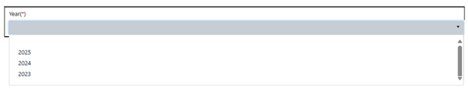
- Reporting can only be completed for one quarter and an associated year per report.
- Select the appropriate Year for the Quarterly Report.
- If the Permittee ID, Quarter or Year are changed, the pop-up message below will display.
  - Clicking OK will update the eForm with the new values.
  - Clicking Cancel will return the values to what they were before the field was changed.
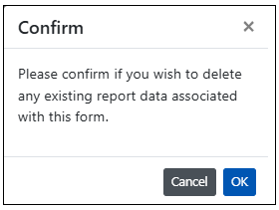
- At this point in the quarterly reporting process, the eForm can be saved to be completed later by clicking on the “Click to Save for Future Retrieval button”
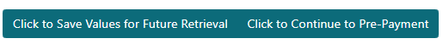
or quarterly reporting can continue by clicking on the Quarterly Fee Report Part 1 tab.
- Clicking on the “Click to Continue to Pre-Payment” at any point without having filled in all required fields on all tabs will display the error message below indicating that not all the required information has been entered. In this example, the first fields with an error are checkbox fields indicating whether coal was produced during the selected Quarter.
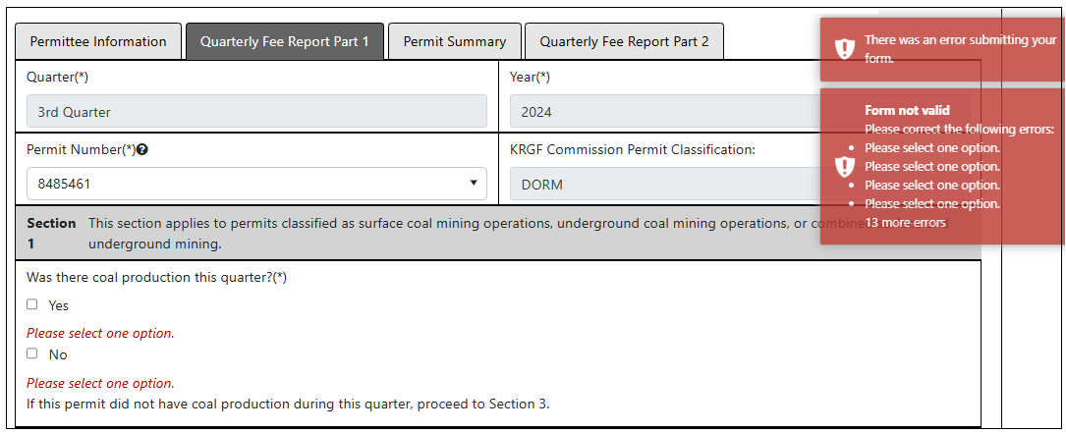

Quarterly Fee Report Part 1 Tab
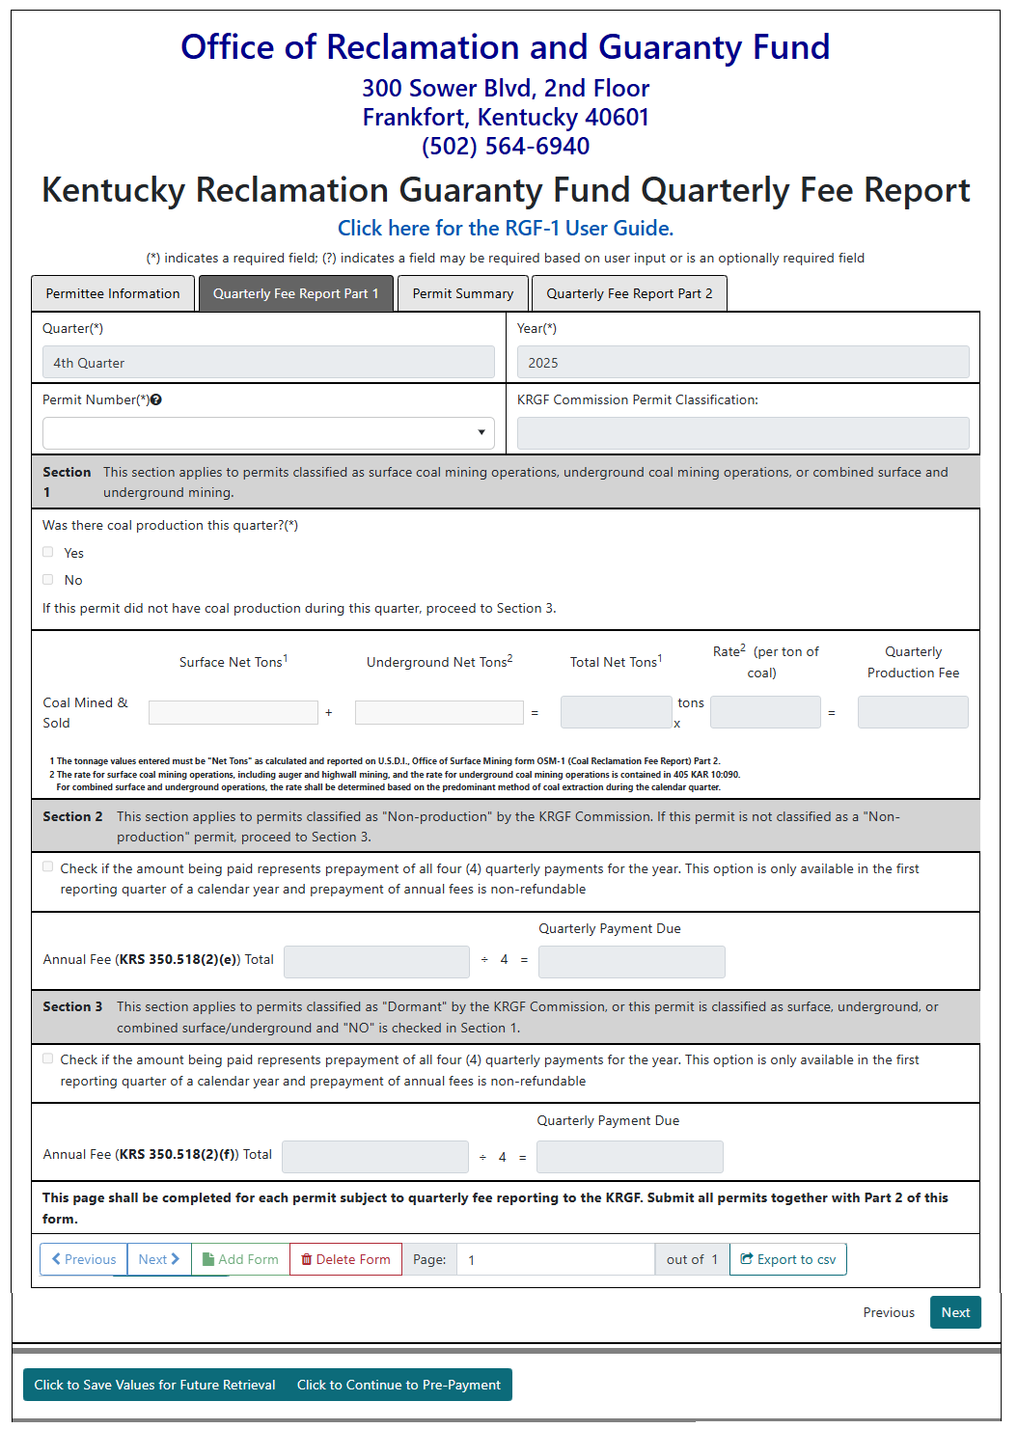
- The Quarterly Fee Report Part 1 tab consists of a header area, Section 1 for reporting tonnage, Section 2 for permits classified as Non-Production, Section 3 for permits classified as Dormant and the navigation controls for adding / deleting a form for the Quarterly Report and saving or proceeding to pre-payment.
- The Quarter and Year fields are populated with the values that were selected on the Permittee Information tab and are protected.
- The Permit Number dropdown will display the list of permits that have an annual classification for the Quarter and Year. If the “Check here if this is an amended or corrected Quarterly Fee Report” checkbox was checked on the Permittee Information tab, only permits that have previously been reported on will display. If it was not checked, only permits that have not had a quarterly report for the reporting Quarter and Year will display for selection.
- Click on the Permit Number dropdown to select a permit. The KRGF Commission Permit Classification field will auto-populate with the annual classification for the permit number selected in the dropdown. The annual classifications are Combination (COMB), Dormant (DORM), Non-Production (NPRD), Surface (SURF) or Underground (UNDG).

Reporting for Permits Classified as COMB, SURF and UNDG
- Section 1 will be enabled, Sections 2 and 3 will be disabled.
- The “Was there coal production this quarter” Yes and No checkboxes will be enabled and selecting one is required.
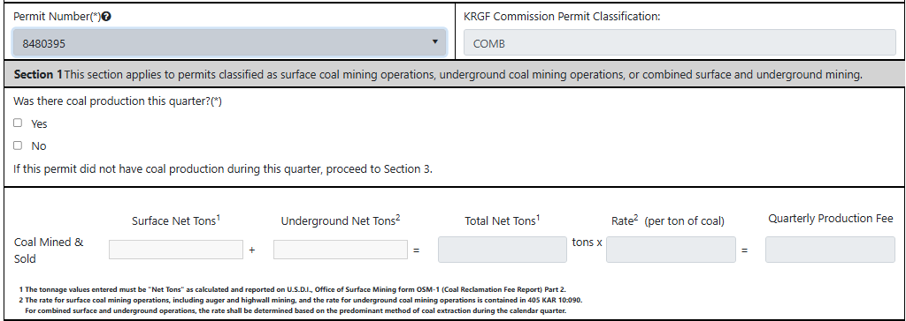

- If tonnage is not going to be reported, select the No checkbox.
  - The Surface Net Tons field will be disabled.
  - The Underground Net Tons field will be disabled.
  - Section 2 is disabled.
  - Section 3 will be populated with the default DORM fee for the bonded acreage based on the annual classification for the permit. The default Dorm amount due will be the bonded acreage multiplied by the KRGF Dormant Mining Operation fee divided by 4. At this time of this writing the KRGF DORM rate is $6.00 per bonded acre.

Example calculation: 100 bonded acres x $6.00 DORM rate = $600.00 annual fee / 4 = $150.00 quarterly fee

  - The pre-pay for all 4 quarters checkbox in Section 3 is enabled if the date is between January 1 and April 30 of the reporting year.
    - To pre-pay for all 4 quarters:
      - Select the pre-pay option and the amount due in Section 3 would be the total quarterly fees for Q1, Q2, Q3 and Q4.
    - To pay for only the reporting quarter, do not select the pre-pay option, the amount due in Section 3 will only include the Quarterly fees for the reporting quarter.
  - If it is between May 1 and December 31, the amount due in Section 3 will be the quarterly fees for the quarter you are reporting for.

- If tonnage is going to be reported, select the Yes checkbox.
  - The Surface Net Tons or the Underground Net Tons fields must have a value, or both can have a value with the rate based on the predominant method of coal extraction.
  - The Quarterly Production Fee will be calculated based on the type of tonnage produced and tonnage amount entered.
  - Section 2 is disabled.
  - Section 3 is disabled.
Example reporting coal production for surface tons for a permit:
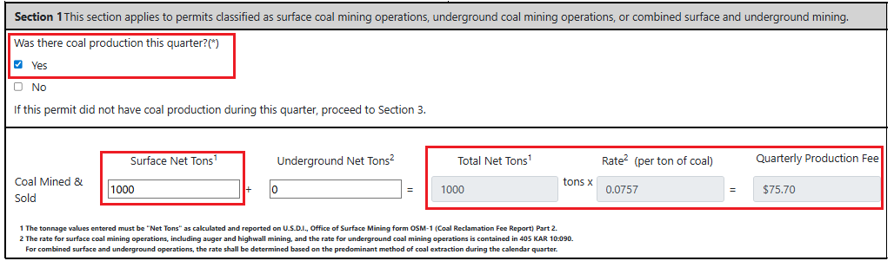

Reporting for Permits Classified as NPRD
- The “Check here if this is an amended or corrected Quarterly Fee Report” checkbox will be disabled.
- Section 1 is disabled because tonnage cannot be report for NPRD classified permits.
- Section 3 for permits classified as Dormant is disabled.
- The pre-pay for all 4 quarters checkbox in Section 2 is enabled if the date is between January 1 and April 30 of the reporting year.
  - To pre-pay for all 4 quarters:
    - Select the pre-pay option and the amount due in Section 2 would be the total quarterly fees for Q1, Q2, Q3 and Q4.
    - To pay for only the reporting quarter, do not select the pre-pay option, the amount due in Section 2 will only include the quarterly fees for the reporting quarter.
  - If it is between May 1 and December 31, the amount due in Section 2 would be the quarterly fees for the quarter you are reporting for.
- You cannot change the amount due.
Example reporting for a NPRD classified permit:
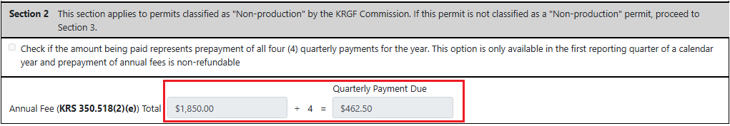

Reporting for Permits Classified as DORM
- The “Check here if this is an amended or corrected Quarterly Fee Report” checkbox will be disabled.
- Section 1 is enabled because tonnage can be reported for DORM classified permits.
- Section 2 is disabled.
- If tonnage is not going to be reported, select the No checkbox.
- The Surface Net Tons field will be disabled.
- The Underground Net Tons field will be disabled.
- The pre-pay for all 4 quarters checkbox in Section 3 is enabled if the date is between January 1 and April 30 of the reporting year.
  - To pre-pay for all 4 quarters:
    - Select the pre-pay option and the amount due in Section 3 would be the total quarterly fees for Q1, Q2, Q3 and Q4.
    - To pay for only the reporting quarter, do not select the pre-pay option, the amount due in Section 3 will only include the quarterly fees for the reporting quarter.
  - If it is between May 1 and December 31, the amount due in Section 3 would be the quarterly fees for the quarter you are reporting for.
- You cannot change the amount due.
Example reporting for a DORM classified permit with no tonnage reported:
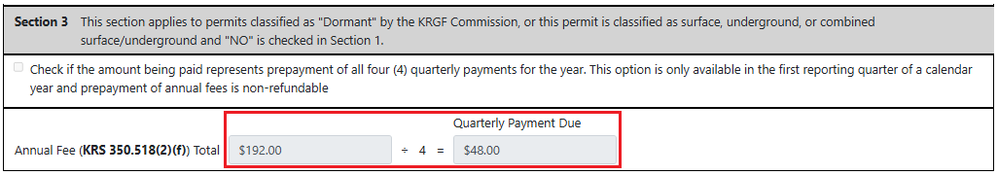
7. If tonnage is going to be reported, select the Yes checkbox.
  - The Surface Net Tons or the Underground Net Tons fields must have a value, or both can have a value with the rate based on the predominant method of coal extraction.
  - The Quarterly Production Fee will be calculated based on the type of tonnage produced and tonnage amount entered.
  - Section 2 is disabled.
  - Section 3 is disabled.

Permit Summary Tab and the Quarterly Fee Report Part 1 Tab
1. The RGF-1 eForm stores the reporting information for each permit on a separate page, like the paper version of the RGF-1 form. There would be 1 piece of paper for each permit and 1 page for Part-2 for the contact information.
For example, if you are reporting for 3 permits, there will be 3 pages on the Quarterly Fee Report Part 1 tab and 3 records in the Permit Summary Tab grid table.
In this example the Quarterly Fee Report Part 1 tab is on page 3.
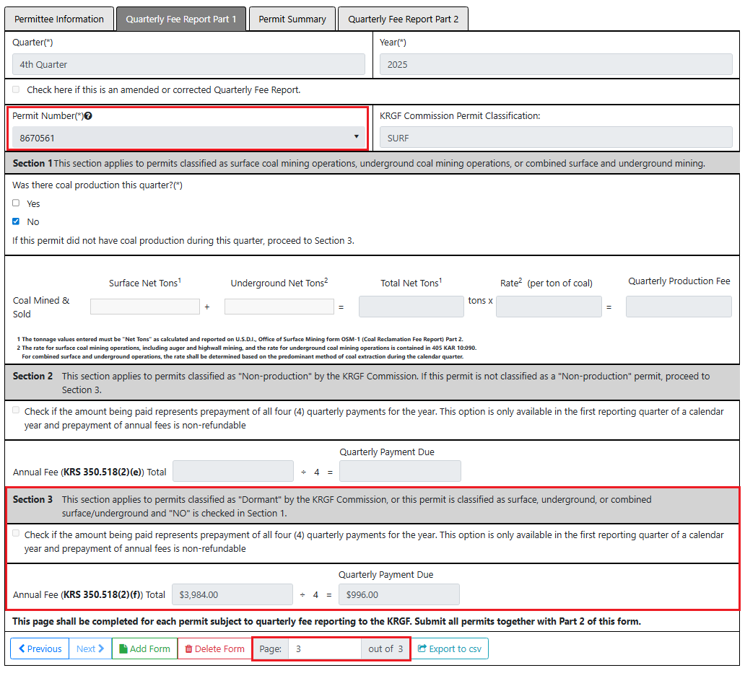

The Permit Summary tab has a corresponding record for each page on the Quarterly Fee Report Part 1 tab.
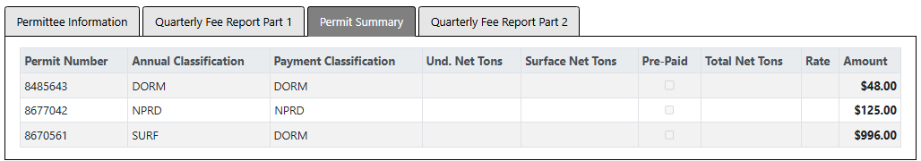

Adding Permit Records to the Quarterly Report

Reporting for only 1 permit
1. When the permit is selected it will display in the grid table on the Permit Summary tab if you click on that tab.
NOTE: Do not click on the Add Form button when adding only 1 permit. If there are multiple permits available for reporting, clicking on the Add Form button will change the Permit Number field to blank. The eForm application is expecting a 2nd page to be added so it will require a permit number to be selected.
If you try to click on the Permit Summary or Quarterly Fee Report Part 2 tabs, an error message will display indicating you need to select another permit.
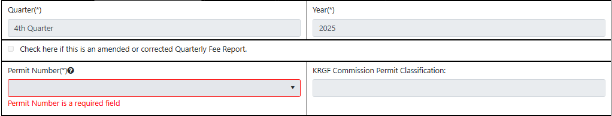

NOTE: If you do click the Add Form button and see the “Permit Number is a required field” error message, clicking on the Delete Form button will reset the eForm to Page 1 and you can continue. If you select a permit number, this step will also reset the eForm.

Reporting for multiple or all permits
1. If you want to report on more than one permit, you will use the Add Form button to add a new page for the permit and the Delete Form button if you need to remove a page.
2. Adding permits to the Quarterly Report will remove them from the dropdown display to prevent them from getting selected multiple times.
3. Deleting a page from the Quarterly Report will add the permit number for that page back to the permit number dropdown.
4. Only 1 page is visible at a time on the Quarterly Fee Report Part 1 tab, but you can page forward and backward using the Next and Previous buttons as pictured above or go directly to a page by entering the page number and clicking enter or tabbing off the page number field.
NOTE: When you have selected the last permit number you want to report on, if there are still permits available for reporting in the dropdown list, do not click the Add Form button. This works the same as described when reporting for only 1 permit.
NOTE: If it is the last permit available for selection, the permit number field will not be cleared and the Add button will be disabled.

Quarterly Fee Report Part 2 Tab
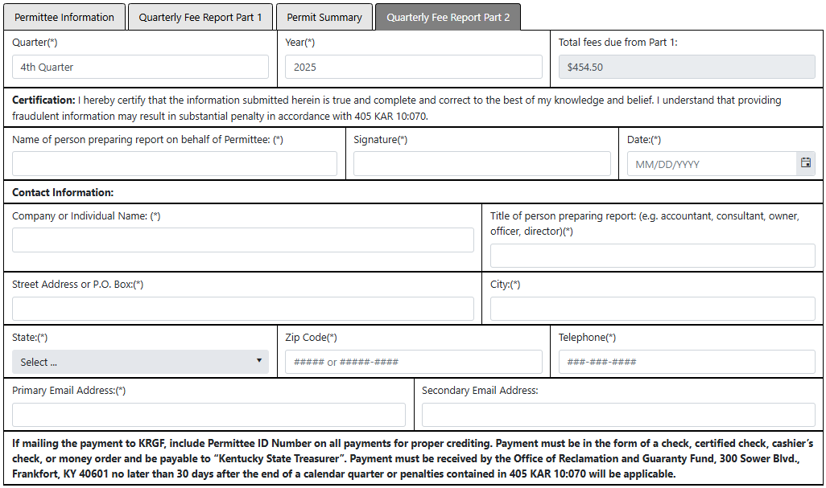

- The Quarterly Fee Report Part 2 tab consists of a header area and a section to enter contact information for the person filing the quarterly report.
- The Quarter and Year fields are populated with the values that were selected on the Permittee Information tab and cannot be changed.
- The “Total fees due from Part 1” is the accumulated fee amounts for all permits on the quarterly report and it cannot be changed.
- All editable fields on the tab are required except for the “Secondary Email Address” field.
- All information is required to be completed before the “Click to Continue to Pre-Payment” button will take you to the pre-payment window.
- The Signature field is a text field and just needs to have something entered in it.
- Any required field that is blank when the “Click to Continue to Pre-Payment” button is clicked will display an error message. In the example below, the “Title of person preparing report” field is missing a value.
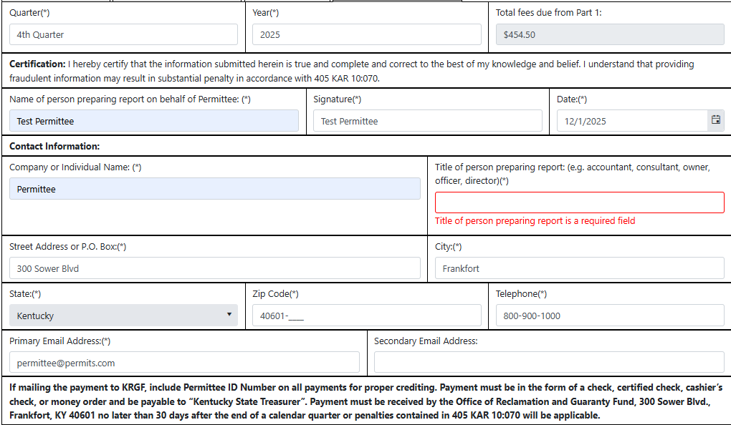

Paying for the Quarterly Report
1. To navigate to the payment module, click the “Click to Continue to Pre-Payment” button.
2. The Quarterly Reporting invoice will be created and added to SMIS and the ORGF will receive an email that the quarterly report was filed.
3. The Team Kentucky Energy and Environment Cabinet payment cart screen will display.
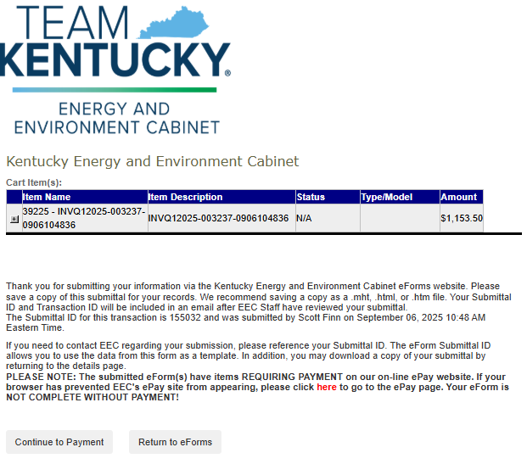
4. The payment cart displays the invoice number that was created and the amount due.
5. Clicking the arrow next to the Item Name will display the invoice details.
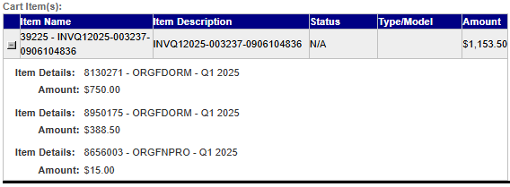
6. If you want to pay the invoice later, clicking the Return to eForms button will take you back to the EEC eForms Form Details page for the eForm.
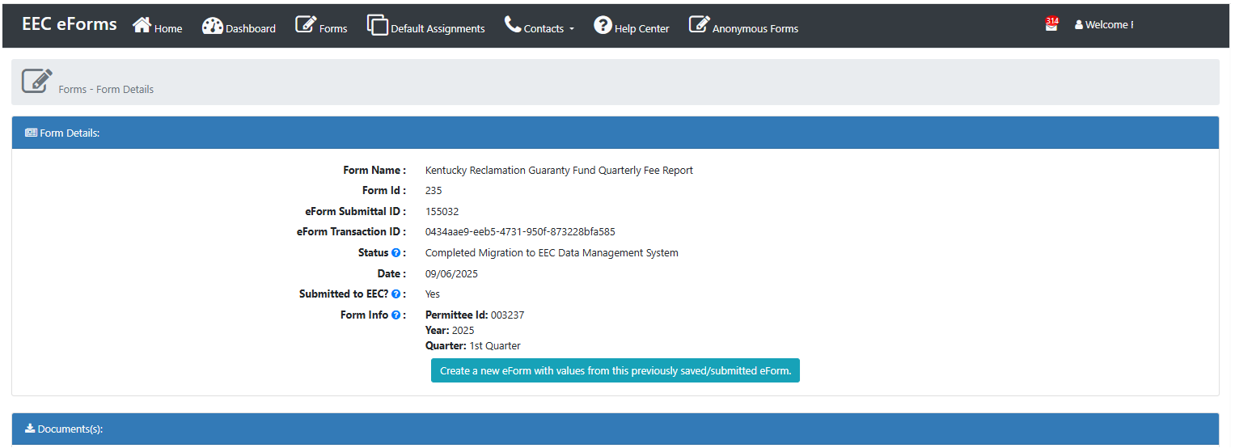
7. If you want to pay the invoice now, clicking the Continue to Payment button will take you to the DEP Payment Processing website.
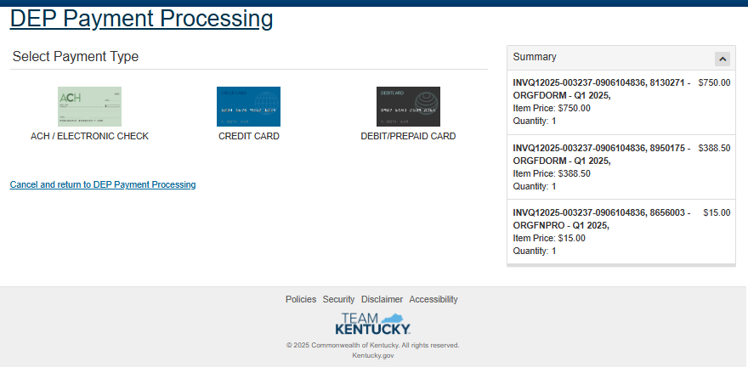
8. On the DEP Payment Processing website you can either pay for the invoice or click “Cancel and return to DEP Payment Processing” which will display the EEC eForms dashboard.

Filing an Amended or Corrected Quarterly Report
- For permits classified as COMB, DORM, SURF and UNDG, an amended or corrected quarterly report can be filed for one or more permits by quarter and year.
- An amended or corrected quarterly report cannot be filed for an NPRD classified permit because tonnage cannot be reported on an NPRD classified permit. Permits classified as NPRD will not be displayed in the list of selectable permits.
- The filing an amended or corrected report process is like filing the initial quarterly report, with the difference being you will need to check the “Check here if this is an amended or corrected Quarterly Fee Report” to display the permits for selection that have been reported on for the Quarter and Year.
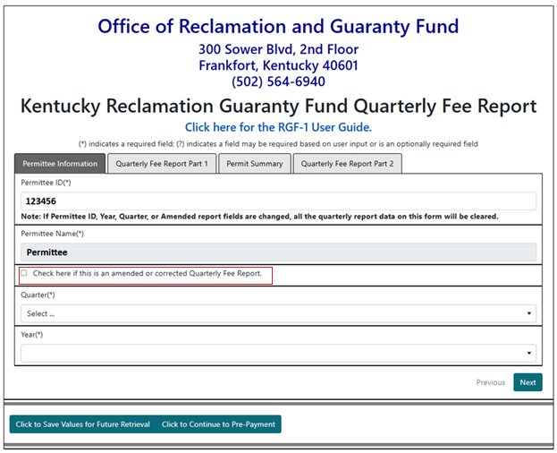
- On the Quarterly Fee Report Part 1 tab, if the “Check here if this is an amended or corrected Quarterly Fee Report” checkbox was clicked on the Permittee Information tab and either the company has only permits classified as NPRD or there are not any non-NPRD Classified permits that have a Quarterly Report on file for that Quarter and Year, the message below will display when the Permit Number dropdown is selected.
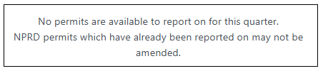
- For “Was there coal production this quarter?” the Yes checkbox must be checked for the Surface Net Tons and Underground Net Tons to be enabled.
- The Surface Net Tons or the Underground Net Tons fields must have a value, or both can have a value with the rate based on the predominant method of coal extraction.
- The Quarterly Production Fee will be calculated based on the type of tonnage produced and tonnage amount entered.
- Section 2 is disabled.
- Section 3 is disabled.

