Laboratory Certification Corrective Action Guidance

The information found within this document should be consulted in the event that the Laboratory needs to perform Corrective Action, including a Corrective Action Request concerning two consecutive unsuccessful Proficiency Test (PT) analyses. The Laboratory will need to conduct an investigation, or Root Cause Analysis, in order to determine the fundamental cause of the unsuccessful analyses. Once the Laboratory has identified the root cause of the issue, they may then begin developing their plan for Corrective Action to help ensure the issue does not happen again.

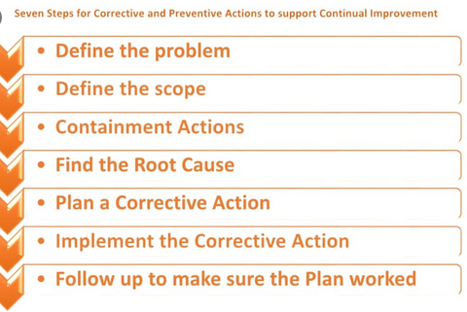
Root Cause Analysis is the problem-solving method in which the initial factor of an undesirable outcome is identified through investigation. There are many different approaches and techniques to Root Cause Analysis as the investigation is unique to each situation; however, they all begin by asking about why the issue occurred.
The image above references information found within ISO 9001. ISO 9001 is the international standard for a quality management system. For more information, please visit: https://www.iso.org/iso-9001-quality-management.html

Corrective Action is the process in which the factors that contributed to the undesirable outcome are eliminated. A satisfactory corrective action plan ensures that the issue is not reoccurring and all factors, including the root cause, have been removed from all workflows, processes, and/or methodologies. It is important not to make too many corrective actions at once. It is usually best to only make one at a time so that you can easily determine the effectiveness of the change.

Root Cause Analysis and Corrective Action Example

To help illustrate the concepts of Root Cause Analysis and Corrective Action, please consider the following example:

Root Cause Analysis:

A Laboratory has just received their second “Not Acceptable” Proficiency Test (PT) result for pH analysis. The Lab Manager interviews the analyst that performed the PTs and finds out that the pH meter was not calibrated before either of the analyses.

While interviewing the analyst further, it is discovered that the analyst did not know that the pH meter must be calibrated with each use and was never taught how to properly calibrate the pH meter.
While investigating this matter, it is also found that no information concerning pH meter calibration exists within the Laboratory’s training documentation and SOPs.

All of the above information of the example is the Root Cause Analysis. While it may seem as if the cause for the unsuccessful PT results was that the analyst wasn’t calibrating the meter, the Root Cause is actually that there is insufficient analyst training and training materials to perform the analyses.

Corrective Action(s):

The Laboratory can now begin working on correcting the issue. The Laboratory develops an SOP that includes pH meter calibration in detail. The Laboratory also retrains their analysts using the new SOP and documents the training in their employee records. The Laboratory ensures that the SOP is easily accessible to anyone performing the analysis. The analysts use the new SOP and their training to perform another PT. The Laboratory continues to review the SOP annually and revise it as necessary.

All of the above information of the example are the Corrective Actions. This Corrective Action didn’t stop at developing a new SOP; to ensure the issue is eliminated, corrective action must be continual.

The document found on the next page is a template provided to assist the Laboratory in documenting their Corrective Action. Laboratories are encouraged to use this template for other instances in which Corrective Action is necessary. For example, this process can also be used in the event of multiple failed calibration verification samples.

Should you have any questions or require further information, please contact the KY Division of Water, Laboratory Certification section at DOWLabCertification@ky.gov.

Corrective Action Documentation Template

Lab Name |  | Lab  ID
Date(s) of Occurrence(s) |  | Lab Contact Name

Description of the Issue
Type of Analysis
Analyst Name
Root Cause Analysis
Corrective Action(s) Taken
Dates of Corrective Action(s) Taken
Outcome and Conclusion
Corrective Action Concluded By

